How to use Web Time Entry Supervisor/Employee

# Set up Pay Periods

1. Log in as an Approver

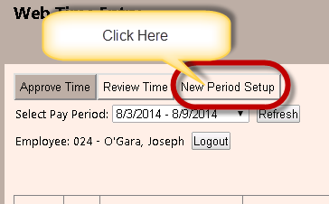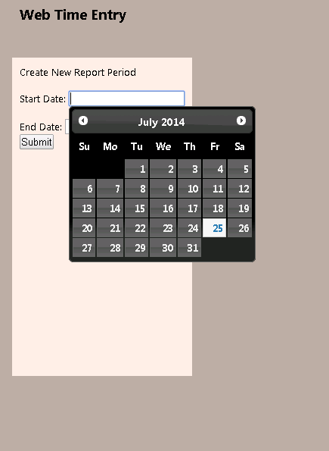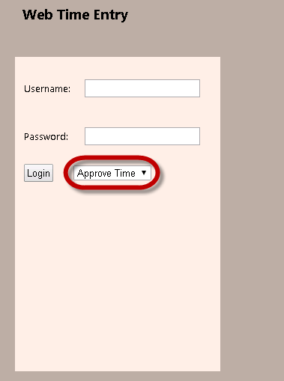

1. Fill In the Start and End Dates and hit Submit

# Review Time as a Supervisor

1. Log in as the Approver



# C:\Users\balm_000\AppData\Local\Temp\SNAGHTML62e54a51.PNG

# Enter and Fix Time as an Employee

1. Log in under Enter Time on the Log In Screen

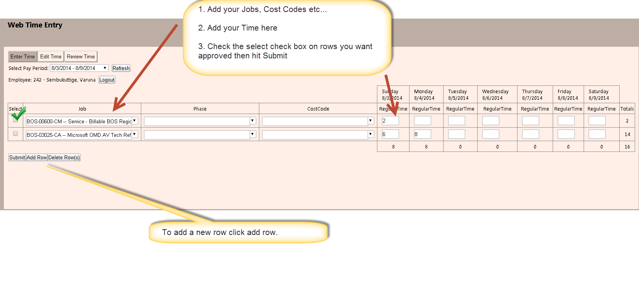

1. Fix rejected time

